

Université Abdelmalek Essaadi 2022/2023 Faculté des Sciences et Techniques-Tanger Département Génie Informatique LST GI S6 POO JAVA

**MINI PROJET :**

**Tracking Des Livreurs**



**Réalisé par :**

**EL IDRISSI Aziza grp2**

**Encadre par :**

**M. EN-NAIMI**

[**Lelaachak**](https://mail.google.com/mail/?view=cm&fs=1&to=lelaachak%40uae.ac.ma&authuser=0) **Lotfi**

**Année universitaire 2022-2023**

Plan :

* Introduction
* Plan du travail
* Les outils
* Interface Menu ,MenuApp , Menu.fxml, Menu.Controller
* Interface Livreur , Livreur.fxml, Livreur.Controller
* Interface Produit , Produit.fxml, Produit.Controller
* Interface Commande , Commande.fxml, Commande.Controller
* Base donnees
* Table livreur
* Table produit
* Table commande
* Conclusion

Introduction :

Cette application est une application de gestion de livraison elle sert facilite les méthodes de supprimer et ajouter et modifier un élément de tableau soit de type livreur ou produit ou commande, relier avec la base de données SQL.

Plan du travail:

1. **Installer intellij idea, javaFX, scene builder, mysql_connector_java.**
2. **Création les interfaces Menu (Dashboard), livreur, produit, commande en fichiers fxml.**
3. **Créer les classes livreur, produit, commande.**
4. **Traiter les méthodes de chaque interface en Controller.**
5. **Création base de données.**
6. **Lier les interfaces avec base données.**
7. **Liaison entre les interfaces.**
8. **Créer classe MenuApp pour lancer l’application.**

Les outiles :

1. **Intellij IDEA** également appelé « IntelliJ », « IDEA » ou « IDJ » est un environnement de développement intégré (en anglais [Integrated Development Environment](https://fr.wikipedia.org/wiki/Environnement_de_d%C3%A9veloppement_int%C3%A9gr%C3%A9) - IDE) destiné au développement de logiciels informatiques reposant sur la technologie [Java](https://fr.wikipedia.org/wiki/Java_(technique)). Il est développé par [JetBrains](https://fr.wikipedia.org/wiki/JetBrains" \o "JetBrains) (anciennement « IntelliJ ») et disponible en deux versions, l'une communautaire, [open source](https://fr.wikipedia.org/wiki/Open_source), sous [licence Apache 2](https://fr.wikipedia.org/wiki/Licence_Apache) et l'autre propriétaire, protégée par une [licence commerciale](https://fr.wikipedia.org/w/index.php?title=Licence_commerciale&action=edit&redlink=1). Tous deux supportent les langages de programmation [Java](https://fr.wikipedia.org/wiki/Java_(langage)), [Kotlin](https://fr.wikipedia.org/wiki/Kotlin_(langage)" \o "Kotlin (langage)), [Groovy](https://fr.wikipedia.org/wiki/Groovy_(langage)) et [Scala](https://fr.wikipedia.org/wiki/Scala_(langage)).
2. **Java** est un langage de programmation de haut niveau orienté objet créé par James Gosling et Patrick Naughton, employés de Sun Microsystems, avec le soutien de Bill Joy, présenté officiellement le 23 mai 1995 .
3. **JavaFX** est un framework et une bibliothèque d'interface utilisateur issue du projet OpenJFX, qui permet aux développeurs Java de créer une interface graphique .
4. **Scene Builder** est un outil interactif de conception d'interface graphique pour JavaFX. Créé par Oracle, il permet de construire rapidement des interfaces utilisateurs sans avoir besoin de coder. Le logiciel est décliné en deux versions : l'une destiné à JavaFX 8 et l'autre pour JavaFX 9 et plus.
5. **MySQL** est un système de gestion de bases de données relationnelles. Il est distribué sous une double licence GPL et propriétaire.

Menu :

Le menu de notre application contient 3 zones chaque zone a un tableau relier avec la base de données.

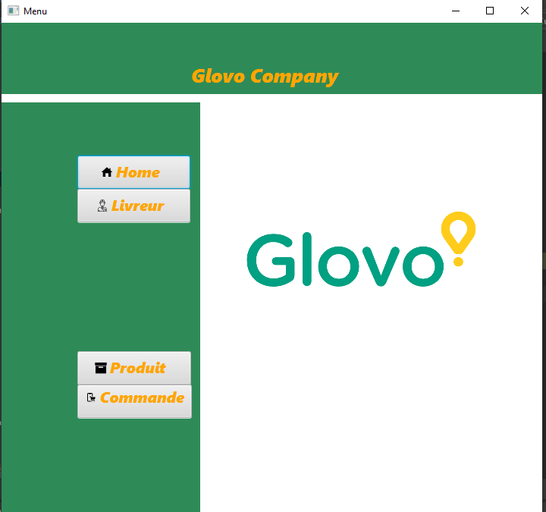

Pour lancer l’application MenuApp :

package ma.fst.trackingl_g2;

import javafx.application.Application;

import javafx.fxml.FXMLLoader;

import javafx.scene.Parent;

import javafx.scene.Scene;

import javafx.stage.Stage;

public class MenuApp extends Application {

@Override

public void start(Stage stage) throws Exception {

Parent parent = FXMLLoader.load(getClass().getResource("Menu.fxml"));

Scene scene = new Scene(parent);

stage.setTitle("Menu");

stage.setScene(scene);

stage.show();

}

public static void main(String[] args) {

launch();

}

}

Fichier MENU FXML :

<?import javafx.geometry.Insets?>

<?import javafx.scene.control.Button?>

<?import javafx.scene.control.Label?>

<?import javafx.scene.image.Image?>

<?import javafx.scene.image.ImageView?>

<?import javafx.scene.layout.AnchorPane?>

<?import javafx.scene.layout.VBox?>

<?import javafx.scene.text.Font?>

<AnchorPane fx:id="root" prefHeight="645.0" prefWidth="713.0" style="-fx-background-color: white;" xmlns="http://javafx.com/javafx/19" xmlns:fx="http://javafx.com/fxml/1" fx:controller="ma.fst.trackingl_g2.MenuController">

<children>

<VBox prefHeight="94.0" prefWidth="713.0" style="-fx-background-color: #2E8B57;" AnchorPane.leftAnchor="0.0" AnchorPane.rightAnchor="0.0" AnchorPane.topAnchor="0.0">

<children>

<Label prefHeight="40.0" prefWidth="205.0" text="Glovo Company" textFill="ORANGE">

<VBox.margin>

<Insets left="250.0" top="50.0" />

</VBox.margin>

<font>

<Font name="Segoe UI Black Italic" size="25.0" />

</font>

</Label>

</children>

</VBox>

<VBox layoutY="105.0" prefHeight="542.0" prefWidth="262.0" style="-fx-background-color: #2E8B57;" AnchorPane.bottomAnchor="-2.0" AnchorPane.leftAnchor="0.0" AnchorPane.topAnchor="105.0">

<children>

<Button mnemonicParsing="false" onMouseClicked="#home" prefHeight="44.0" prefWidth="149.0" text="Home" textFill="ORANGE">

<VBox.margin>

<Insets left="100.0" top="70.0" />

</VBox.margin>

<font>

<Font name="Segoe UI Black Italic" size="20.0" />

</font>

<graphic>

<ImageView fitHeight="16.0" fitWidth="16.0" pickOnBounds="true" preserveRatio="true">

<image>

<Image url="@icons8-page-d’accueil-16.png" />

</image>

</ImageView>

</graphic>

<padding>

<Insets right="10.0" />

</padding>

</Button>

<Button layoutX="110.0" layoutY="80.0" mnemonicParsing="false" onMouseClicked="#livreur" prefHeight="44.0" prefWidth="149.0" text="Livreur" textFill="ORANGE">

<font>

<Font name="Segoe UI Black Italic" size="20.0" />

</font>

<graphic>

<ImageView fitHeight="16.0" fitWidth="16.0" pickOnBounds="true" preserveRatio="true">

<image>

<Image url="@icons8-livreur-16.png" />

</image>

</ImageView>

</graphic>

<VBox.margin>

<Insets bottom="100.0" left="100.0" />

</VBox.margin>

<padding>

<Insets right="10.0" />

</padding>

</Button>

<Button layoutX="110.0" layoutY="124.0" mnemonicParsing="false" onMouseClicked="#produit" prefHeight="44.0" prefWidth="150.0" text="Produit" textFill="ORANGE">

<font>

<Font name="Segoe UI Black Italic" size="20.0" />

</font>

<graphic>

<ImageView fitHeight="16.0" fitWidth="16.0" pickOnBounds="true" preserveRatio="true">

<image>

<Image url="@icons8-boîte-16.png" />

</image>

</ImageView>

</graphic>

<VBox.margin>

<Insets left="100.0" top="70.0" />

</VBox.margin>

<padding>

<Insets right="10.0" />

</padding>

</Button>

<Button layoutX="110.0" layoutY="124.0" mnemonicParsing="false" onMouseClicked="#commande" prefHeight="44.0" prefWidth="151.0" text="Commande" textFill="ORANGE">

<font>

<Font name="Segoe UI Black Italic" size="20.0" />

</font>

<graphic>

<ImageView fitHeight="16.0" fitWidth="16.0" pickOnBounds="true" preserveRatio="true">

<image>

<Image url="@icons8-commander-sur-mobile-16.png" />

</image>

</ImageView>

</graphic>

<VBox.margin>

<Insets left="100.0" />

</VBox.margin>

<padding>

<Insets bottom="10.0" />

</padding>

</Button>

</children>

</VBox>

<ImageView fitHeight="175.0" fitWidth="329.0" layoutX="317.0" layoutY="211.0" pickOnBounds="true" preserveRatio="true">

<image>

<Image url="@glovo-logo-vector.png" />

</image>

</ImageView>

</children>

</AnchorPane>

Fichier Menu Controller :

package ma.fst.trackingl_g2;

import javafx.fxml.FXML;

import javafx.fxml.FXMLLoader;

import javafx.fxml.Initializable;

import javafx.scene.Parent;

import javafx.scene.input.MouseEvent;

import javafx.scene.layout.AnchorPane;

import java.io.IOException;

import java.net.URL;

import java.util.ResourceBundle;

public class MenuController implements Initializable {

private Parent fxml;

@FXML

private AnchorPane root;

@FXML

void commande(MouseEvent event) {

try {

fxml= FXMLLoader.load(getClass().getResource("Commande.fxml"));

root.getChildren().removeAll();

root.getChildren().setAll(fxml);

} catch (IOException e) {

e.printStackTrace();

}

}

@FXML

void home(MouseEvent event ) {

try {

fxml= FXMLLoader.load(getClass().getResource("Menu.fxml"));

root.getChildren().removeAll();

root.getChildren().setAll(fxml);

} catch (IOException e) {

e.printStackTrace();

}

}

@FXML

void livreur(MouseEvent event) {

try {

fxml= FXMLLoader.load(getClass().getResource("Livreur.fxml"));

root.getChildren().removeAll();

root.getChildren().setAll(fxml);

} catch (IOException e) {

e.printStackTrace();

}

}

@FXML

void produit(MouseEvent event) {

try {

fxml= FXMLLoader.load(getClass().getResource("Produit.fxml"));

root.getChildren().removeAll();

root.getChildren().setAll(fxml);

} catch (IOException e) {

e.printStackTrace();

}

}

@Override

public void initialize(URL url, ResourceBundle resourceBundle) {

}

}

Livreur:

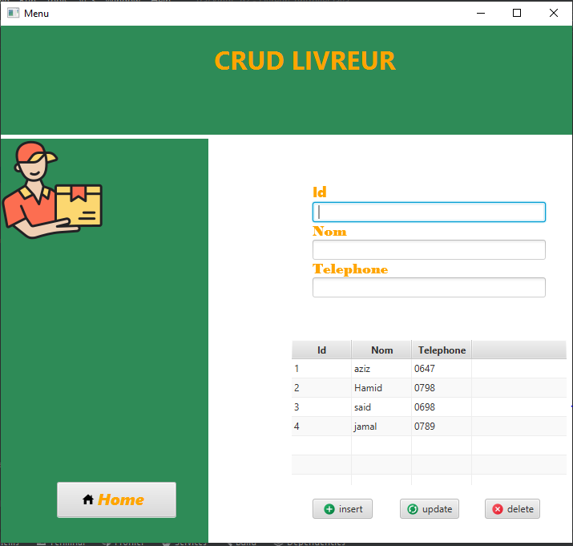

Classe Livreur :

package ma.fst.trackingl_g2;

public class Livreur {

private Long id_livreur ;

private String nom ;

private String telephone ;

public Livreur() {

}

public Livreur(Long id_livreur, String nom, String telephone) {

this.id_livreur = id_livreur;

this.nom = nom;

this.telephone = telephone;

}

public Long getId_livreur() {

return id_livreur;

}

public void setId_livreur(Long id_livreur) {

this.id_livreur = id_livreur;

}

public String getNom() {

return nom;

}

public void setNom(String nom) {

this.nom = nom;

}

public String getTelephone() {

return telephone;

}

public void setTelephone(String telephone) {

this.telephone = telephone;

}

@Override

public String toString() {

return "Livreur{" +

"id_livreur=" + id_livreur +

", nom='" + nom + '\'' +

", telephone='" + telephone + '\'' +

'}';

}

}

Fichier Livreur Fxml :

<?xml version="1.0" encoding="UTF-8"?>

<?import javafx.geometry.Insets?>

<?import javafx.scene.control.Button?>

<?import javafx.scene.control.Label?>

<?import javafx.scene.control.TableColumn?>

<?import javafx.scene.control.TableView?>

<?import javafx.scene.control.TextField?>

<?import javafx.scene.image.Image?>

<?import javafx.scene.image.ImageView?>

<?import javafx.scene.layout.AnchorPane?>

<?import javafx.scene.layout.VBox?>

<?import javafx.scene.text.Font?>

<?import javafx.scene.text.Text?>

<AnchorPane fx:id="root" prefHeight="693.0" prefWidth="721.0" style="-fx-background-color: white;" styleClass="form_container" xmlns="http://javafx.com/javafx/19" xmlns:fx="http://javafx.com/fxml/1" fx:controller="ma.fst.trackingl_g2.LivreurController">

<children>

<VBox layoutX="389.0" layoutY="195.0" prefHeight="171.0" prefWidth="291.0" AnchorPane.leftAnchor="389.0" AnchorPane.topAnchor="195.0">

<children>

<Text fill="ORANGE" layoutX="10.0" layoutY="23.0" strokeType="OUTSIDE" strokeWidth="0.0" text="Id" wrappingWidth="26.259765625">

<font>

<Font name="Segoe UI Black" size="18.0" />

</font></Text>

<TextField fx:id="id" layoutX="10.0" layoutY="68.0" />

<Text fill="ORANGE" strokeType="OUTSIDE" strokeWidth="0.0" text="Nom">

<font>

<Font name="Bodoni MT Black" size="18.0" />

</font></Text>

<TextField fx:id="nom" />

<Text fill="ORANGE" strokeType="OUTSIDE" strokeWidth="0.0" text="Telephone">

<font>

<Font name="Bodoni MT Black" size="18.0" />

</font></Text>

<TextField fx:id="tele" />

</children>

</VBox>

<TableView fx:id="mytable" layoutX="362.0" layoutY="391.0" onMouseClicked="#handleMouseAction" prefHeight="183.0" prefWidth="345.0" style="-fx-background-color: white;" AnchorPane.rightAnchor="14.0" AnchorPane.topAnchor="391.0">

<columns>

<TableColumn fx:id="col_id" prefWidth="75.0" style="color: white;" text="Id" />

<TableColumn fx:id="col_nom" prefWidth="75.0" text="Nom" />

<TableColumn fx:id="col_tele" prefWidth="75.0" text="Telephone" />

</columns>

</TableView>

<Button fx:id="btdelete" layoutX="604.0" layoutY="590.0" mnemonicParsing="false" onAction="#handleButtonAction" text="delete">

<graphic>

<ImageView fitHeight="16.0" fitWidth="16.0" pickOnBounds="true" preserveRatio="true">

<image>

<Image url="@icons8-annuler-16.png" />

</image>

</ImageView>

</graphic></Button>

<Button fx:id="btupdate" layoutX="498.0" layoutY="590.0" mnemonicParsing="false" onAction="#handleButtonAction" text="update">

<graphic>

<ImageView fitHeight="16.0" fitWidth="16.0" pickOnBounds="true" preserveRatio="true">

<image>

<Image url="@icons8-syncronisation-connexion-16.png" />

</image>

</ImageView>

</graphic></Button>

<Button fx:id="btinsert" layoutX="389.0" layoutY="590.0" mnemonicParsing="false" onAction="#handleButtonAction" prefHeight="25.0" prefWidth="75.0" text="insert">

<graphic>

<ImageView fitHeight="16.0" fitWidth="16.0" pickOnBounds="true" preserveRatio="true">

<image>

<Image url="@icons8-ajouter-16.png" />

</image>

</ImageView>

</graphic></Button>

<VBox layoutY="141.0" prefHeight="552.0" prefWidth="259.0" style="-fx-background-color: #2E8B57;" AnchorPane.bottomAnchor="0.0" AnchorPane.leftAnchor="0.0" AnchorPane.topAnchor="141.0">

<children>

<ImageView fitHeight="128.0" fitWidth="128.0" pickOnBounds="true" preserveRatio="true">

<image>

<Image url="@delivery-man.png" />

</image>

</ImageView>

<Button mnemonicParsing="false" onMouseClicked="#home" prefHeight="44.0" prefWidth="149.0" text="Home" textFill="ORANGE">

<VBox.margin>

<Insets left="70.0" top="300.0" />

</VBox.margin>

<font>

<Font name="Segoe UI Black Italic" size="20.0" />

</font>

<graphic>

<ImageView fitHeight="16.0" fitWidth="16.0" pickOnBounds="true" preserveRatio="true">

<image>

<Image url="@icons8-page-d’accueil-16.png" />

</image>

</ImageView>

</graphic>

<padding>

<Insets right="10.0" />

</padding>

</Button>

</children>

</VBox>

<VBox layoutX="257.0" prefHeight="136.0" prefWidth="721.0" style="-fx-background-color: #2E8B57;" AnchorPane.bottomAnchor="557.0" AnchorPane.leftAnchor="0.0" AnchorPane.rightAnchor="0.0" AnchorPane.topAnchor="0.0">

<children>

<Label alignment="CENTER" prefHeight="47.0" prefWidth="259.0" styleClass="title" text="CRUD LIVREUR" textFill="ORANGE">

<font>

<Font name="System Bold" size="32.0" />

</font>

<VBox.margin>

<Insets left="250.0" top="20.0" />

</VBox.margin>

</Label>

</children>

</VBox>

</children>

</AnchorPane>

Fichier Livreur Controller :

package ma.fst.trackingl_g2;

import javafx.collections.FXCollections;

import javafx.collections.ObservableList;

import javafx.event.ActionEvent;

import javafx.fxml.FXML;

import javafx.fxml.FXMLLoader;

import javafx.fxml.Initializable;

import javafx.scene.Parent;

import javafx.scene.control.Button;

import javafx.scene.control.TableColumn;

import javafx.scene.control.TableView;

import javafx.scene.control.TextField;

import javafx.scene.control.cell.PropertyValueFactory;

import javafx.scene.layout.AnchorPane;

import org.w3c.dom.events.MouseEvent;

import java.io.IOException;

import java.net.URL;

import java.sql.Connection;

import java.sql.DriverManager;

import java.sql.ResultSet;

import java.sql.Statement;

import java.util.ResourceBundle;

public class LivreurController implements Initializable {

@FXML

private Button btdelete;

@FXML

private Button btinsert;

@FXML

private AnchorPane root;

private Parent fxml;

@FXML

private Button btupdate;

@FXML

private TableColumn<Livreur, Long> col_id;

@FXML

private TableColumn<Livreur, String> col_nom;

@FXML

private TableColumn<Livreur, String> col_tele;

@FXML

private TableView<Livreur> mytable;

@FXML

private TextField nom;

@FXML

private TextField tele;

@FXML

private TextField id;

private URL url;

private ResourceBundle resourceBundle;

@FXML

private void handleButtonAction(ActionEvent actionEvent) {

if (actionEvent.getSource() == this.btinsert) {

this.insertRecord();

} else if (actionEvent.getSource() == this.btupdate) {

this.updateRecord();

} else if (actionEvent.getSource() == this.btdelete) {

this.deleteButton();

}

}

private void deleteButton() {

String query = "DELETE FROM livreur WHERE id_livreur =" + this.id.getText() + "";

this.executeQuery(query);

this.showLivreur();

}

@Override

public void initialize(URL url, ResourceBundle resourceBundle) {

this.url = url;

this.resourceBundle = resourceBundle;

this.showLivreur();

}

public Connection getConnection(){

Connection conn;

try {

;

conn = DriverManager.getConnection("jdbc:mysql://127.0.0.1:3306/glovo","root","");

return conn;

} catch (Exception e) {

System.out.println("Error:"+e.getMessage());

return null;

}

}

public ObservableList<Livreur> getLivreurList(){

ObservableList<Livreur> livreurlist = FXCollections.observableArrayList();

Connection conn = getConnection();

String query ="SELECT * FROM livreur";

Statement st ;

ResultSet rs;

try {

st=conn.createStatement();

rs= st.executeQuery(query);

while (rs.next()){

Livreur livreur = new Livreur(rs.getLong("id_livreur"),rs.getString("nom"), rs.getString("telephone"));

livreurlist.add(livreur);

}

} catch (Exception e) {

e.printStackTrace();

}

return livreurlist;

}

public void showLivreur(){

ObservableList<Livreur> list = this.getLivreurList();

col_id.setCellValueFactory(new PropertyValueFactory<Livreur, Long> ("id_livreur"));

col_nom.setCellValueFactory(new PropertyValueFactory<Livreur, String> ("nom"));

col_tele.setCellValueFactory(new PropertyValueFactory<Livreur, String> ("telephone"));

this.mytable.setItems(list);

}

public void insertRecord() {

String query;

query = "INSERT INTO livreur VALUES ('" + this.nom.getText() + "','" + this.tele.getText() + "'," + this.id.getText() + ")";

this.executeQuery(query);

this.showLivreur();

}

private void updateRecord() {

String query = "UPDATE livreur SET nom = '" + this.nom.getText() + "', telephone = '" + this.tele.getText() + "' WHERE id_livreur = " + this.id.getText();

this.executeQuery(query);

this.showLivreur();

}

private void executeQuery(String query) {

Connection conn = getConnection();

Statement st;

try {

st = conn.createStatement();

st.executeUpdate(query);

} catch (Exception e) {

e.printStackTrace();

}

}

@FXML

private void handleMouseAction(MouseEvent mouseEvent){

Livreur livreur= mytable.getSelectionModel().getSelectedItem();

id.setText(""+livreur.getId_livreur());

nom.setText(livreur.getNom());

tele.setText(livreur.getTelephone());

}

public void handleMouseAction(javafx.scene.input.MouseEvent mouseEvent) {

Livreur livreur= mytable.getSelectionModel().getSelectedItem();

id.setText(""+livreur.getId_livreur());

nom.setText(livreur.getNom());

tele.setText(livreur.getTelephone());

}

public void home(javafx.scene.input.MouseEvent mouseEvent) {

try {

fxml= FXMLLoader.load(getClass().getResource("Menu.fxml"));

root.getChildren().removeAll();

root.getChildren().setAll(fxml);

} catch (IOException e) {

e.printStackTrace();

}

}

}

Produit :

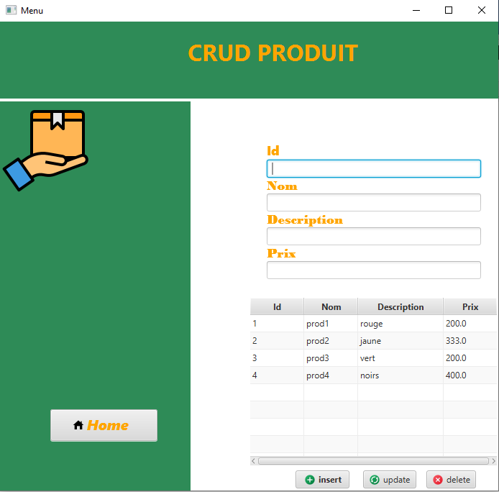

Classe Produit :

package ma.fst.trackingl_g2;

public class Produit {

private Long id_produit ;

private String nom ;

private String description ;

private Float prix ;

public Produit(Long id_produit ,String nom,String description, Float prix) {

this.id_produit = id_produit;

this.nom =nom;

this.description =description;

this.prix =prix;

}

public Produit() {

}

public Long getId_produit() {

return id_produit;

}

public void setId_produit(Long id_produit) {

this.id_produit = id_produit;

}

public String getNom() {

return nom;

}

public void setNom(String nom) {

this.nom = nom;

}

public String getDescription() {

return description;

}

public void setDescription(String description) {

this.description = description;

}

public Float getPrix() {

return prix;

}

public void setPrix(Float prix) {

this.prix = prix;

}

@Override

public String toString() {

return "Produit{" +

"id_produit=" + id_produit +

", nom='" + nom + '\'' +

", description='" + description + '\'' +

", prix=" + prix +

'}';

}

}

Fichier Produit Fxml:

<?xml version="1.0" encoding="UTF-8"?>

<?import javafx.geometry.Insets?>

<?import javafx.scene.control.Button?>

<?import javafx.scene.control.Label?>

<?import javafx.scene.control.TableColumn?>

<?import javafx.scene.control.TableView?>

<?import javafx.scene.control.TextField?>

<?import javafx.scene.image.Image?>

<?import javafx.scene.image.ImageView?>

<?import javafx.scene.layout.AnchorPane?>

<?import javafx.scene.layout.VBox?>

<?import javafx.scene.text.Font?>

<?import javafx.scene.text.Text?>

<AnchorPane prefHeight="663.0" prefWidth="695.0" xmlns="http://javafx.com/javafx/19" xmlns:fx="http://javafx.com/fxml/1" fx:controller="ma.fst.trackingl_g2.ProduitController">

<children>

<AnchorPane fx:id="root" layoutX="10.0" layoutY="10.0" prefHeight="663.0" prefWidth="695.0" style="-fx-background-color: white;" styleClass="form_container" AnchorPane.bottomAnchor="0.0" AnchorPane.leftAnchor="0.0" AnchorPane.rightAnchor="0.0" AnchorPane.topAnchor="0.0">

<children>

<VBox layoutX="371.0" layoutY="167.0" prefHeight="207.0" prefWidth="298.0" AnchorPane.leftAnchor="371.0" AnchorPane.topAnchor="167.0">

<children>

<Text fill="ORANGE" layoutX="10.0" layoutY="23.0" strokeType="OUTSIDE" strokeWidth="0.0" text="Id" wrappingWidth="26.259765625">

<font>

<Font name="Segoe UI Black" size="18.0" />

</font>

</Text>

<TextField fx:id="tid" layoutX="10.0" layoutY="68.0" />

<Text fill="ORANGE" strokeType="OUTSIDE" strokeWidth="0.0" text="Nom">

<font>

<Font name="Bodoni MT Black" size="18.0" />

</font>

</Text>

<TextField fx:id="tnom" />

<Text fill="ORANGE" layoutX="10.0" layoutY="124.0" strokeType="OUTSIDE" strokeWidth="0.0" text="Description">

<font>

<Font name="Bodoni MT Black" size="18.0" />

</font>

</Text>

<TextField fx:id="tdes" layoutX="10.0" layoutY="129.0" />

<Text fill="ORANGE" strokeType="OUTSIDE" strokeWidth="0.0" text="Prix">

<font>

<Font name="Bodoni MT Black" size="18.0" />

</font>

</Text>

<TextField fx:id="tprix" />

</children>

</VBox>

<TableView fx:id="mytable" layoutX="347.0" layoutY="383.0" onMouseClicked="#handleMouseAction" prefHeight="235.0" prefWidth="345.0" style="-fx-background-color: white;" AnchorPane.rightAnchor="3.0" AnchorPane.topAnchor="383.0">

<columns>

<TableColumn fx:id="col_id" prefWidth="75.0" style="color: white;" text="Id" />

<TableColumn fx:id="col_nom" prefWidth="75.0" text="Nom" />

<TableColumn fx:id="col_des" prefWidth="119.0" text="Description" />

<TableColumn fx:id="col_prix" prefWidth="75.0" text="Prix" />

</columns>

</TableView>

<Button fx:id="btdelete" layoutX="593.0" layoutY="624.0" mnemonicParsing="false" onAction="#handleButtonAction" text="delete">

<graphic>

<ImageView fitHeight="16.0" fitWidth="16.0" pickOnBounds="true" preserveRatio="true">

<image>

<Image url="@icons8-annuler-16.png" />

</image>

</ImageView>

</graphic>

</Button>

<Button fx:id="btupdate" layoutX="505.0" layoutY="624.0" mnemonicParsing="false" onAction="#handleButtonAction" text="update">

<graphic>

<ImageView fitHeight="16.0" fitWidth="16.0" pickOnBounds="true" preserveRatio="true">

<image>

<Image url="@icons8-syncronisation-connexion-16.png" />

</image>

</ImageView>

</graphic>

</Button>

<Button fx:id="btinsert" layoutX="411.0" layoutY="624.0" mnemonicParsing="false" onAction="#handleButtonAction" prefHeight="25.0" prefWidth="75.0" text="insert">

<graphic>

<ImageView fitHeight="16.0" fitWidth="16.0" pickOnBounds="true" preserveRatio="true">

<image>

<Image url="@icons8-ajouter-16.png" />

</image>

</ImageView>

</graphic>

<font>

<Font name="System Bold" size="12.0" />

</font>

</Button>

<VBox layoutY="111.0" prefHeight="552.0" prefWidth="265.0" style="-fx-background-color: #2E8B57;" AnchorPane.bottomAnchor="0.0" AnchorPane.leftAnchor="0.0" AnchorPane.topAnchor="111.0">

<children>

<ImageView fitHeight="128.0" fitWidth="128.0" pickOnBounds="true" preserveRatio="true">

<image>

<Image url="@paquete.png" />

</image>

</ImageView>

<Button mnemonicParsing="false" onMouseClicked="#home" prefHeight="44.0" prefWidth="149.0" text="Home" textFill="ORANGE">

<VBox.margin>

<Insets left="70.0" top="300.0" />

</VBox.margin>

<font>

<Font name="Segoe UI Black Italic" size="20.0" />

</font>

<graphic>

<ImageView fitHeight="16.0" fitWidth="16.0" pickOnBounds="true" preserveRatio="true">

<image>

<Image url="@icons8-page-d’accueil-16.png" />

</image>

</ImageView>

</graphic>

<padding>

<Insets right="10.0" />

</padding>

</Button>

</children>

</VBox>

</children>

</AnchorPane>

<VBox layoutX="274.0" layoutY="20.0" prefHeight="107.0" prefWidth="448.0" style="-fx-background-color: #2E8B57;" AnchorPane.leftAnchor="0.0" AnchorPane.rightAnchor="0.0" AnchorPane.topAnchor="0.0">

<children>

<Label alignment="CENTER" prefHeight="47.0" prefWidth="259.0" styleClass="title" text="CRUD PRODUIT" textFill="ORANGE">

<font>

<Font name="System Bold" size="32.0" />

</font>

<VBox.margin>

<Insets left="250.0" top="20.0" />

</VBox.margin>

</Label>

</children>

</VBox>

</children>

</AnchorPane>

Fichier Produit Controller:

package ma.fst.trackingl_g2;

import javafx.collections.FXCollections;

import javafx.collections.ObservableList;

import javafx.event.ActionEvent;

import javafx.fxml.FXML;

import javafx.fxml.FXMLLoader;

import javafx.fxml.Initializable;

import javafx.scene.Parent;

import javafx.scene.control.Button;

import javafx.scene.control.TableColumn;

import javafx.scene.control.TableView;

import javafx.scene.control.TextField;

import javafx.scene.control.cell.PropertyValueFactory;

import javafx.scene.input.MouseEvent;

import javafx.scene.layout.AnchorPane;

import java.io.IOException;

import java.net.URL;

import java.sql.Connection;

import java.sql.DriverManager;

import java.sql.ResultSet;

import java.sql.Statement;

import java.util.ResourceBundle;

public class ProduitController implements Initializable {

private Parent fxml;

@FXML

private AnchorPane root;

@FXML

private Button btdelete;

@FXML

private Button btinsert;

@FXML

private Button btupdate;

@FXML

private TableColumn<Produit, Long> col_id;

@FXML

private TableColumn<Produit, String> col_nom;

@FXML

private TableColumn<Produit,Float> col_prix;

@FXML

private TableColumn<Produit,String> col_des;

@FXML

private TableView<Produit> mytable;

@FXML

private TextField tid;

@FXML

private TextField tnom;

@FXML

private TextField tprix;

@FXML

private TextField tdes;

@FXML

void handleButtonAction(ActionEvent actionEvent) {

if (actionEvent.getSource() == this.btinsert) this.insertRecord();

else if (actionEvent.getSource() == this.btupdate) {

this.updateRecord();

} else if (actionEvent.getSource() == this.btdelete) {

this.deleteButton();

}

}

private void deleteButton() {

String query = "DELETE FROM produit WHERE id_produit =" + this.tid.getText() + "";

this.executeQuery(query);

this.showPoduit();

}

private void updateRecord() {

String query = "UPDATE produit SET nom = '" + this.tnom.getText() + "', description = '" + this.tdes.getText() + "', prix = '" + this.tprix.getText() + "' WHERE id_produit = " + this.tid.getText();

this.executeQuery(query);

this.showPoduit();

}

private void insertRecord() {

String query = "INSERT INTO produit VALUES (" + this.tid.getText() + ",'" + this.tnom.getText() + "','" + this.tdes.getText() + "'," + this.tprix.getText() + ")";

this.executeQuery(query);

this.showPoduit();

}

private void executeQuery(String query) {

Connection conn = getConnection();

Statement st;

try {

st = conn.createStatement();

st.executeUpdate(query);

} catch (Exception e) {

e.printStackTrace();

}

}

@FXML

void handleMouseAction(javafx.scene.input.MouseEvent mouseEvent) {

Produit produit= mytable.getSelectionModel().getSelectedItem();

tid.setText(""+produit.getId_produit());

tnom.setText(produit.getNom());

tdes.setText(produit.getDescription());

tprix.setText(""+produit.getPrix());

}

@Override

public void initialize(URL url, ResourceBundle resourceBundle) {

this.showPoduit();

}

public Connection getConnection(){

Connection conn;

try {

;

conn = DriverManager.getConnection("jdbc:mysql://127.0.0.1:3306/glovo","root","");

return conn;

} catch (Exception e) {

System.out.println("Error:"+e.getMessage());

return null;

}

}

public ObservableList<Produit> getPoduitList(){

ObservableList<Produit> produitlist = FXCollections.observableArrayList();

Connection conn = getConnection();

String query ="SELECT * FROM produit";

Statement st ;

ResultSet rs;

try {

st=conn.createStatement();

rs= st.executeQuery(query);

while (rs.next()){

Produit produit = new Produit(rs.getLong("id_produit"),rs.getString("nom"), rs.getString("description"), rs.getFloat("prix"));

produitlist.add(produit);

}

} catch (Exception e) {

e.printStackTrace();

}

return produitlist;

}

public void showPoduit(){

ObservableList<Produit> list = this.getPoduitList();

col_id.setCellValueFactory(new PropertyValueFactory<Produit, Long>("id_produit"));

col_nom.setCellValueFactory(new PropertyValueFactory<Produit, String> ("nom"));

col_des.setCellValueFactory(new PropertyValueFactory<Produit, String> ("description"));

col_prix.setCellValueFactory(new PropertyValueFactory<Produit, Float> ("prix"));

this.mytable.setItems(list);

}

public void home(MouseEvent mouseEvent) {

try {

fxml= FXMLLoader.load(getClass().getResource("Menu.fxml"));

root.getChildren().removeAll();

root.getChildren().setAll(fxml);

} catch (IOException e) {

e.printStackTrace();

}

}

}

Commande:

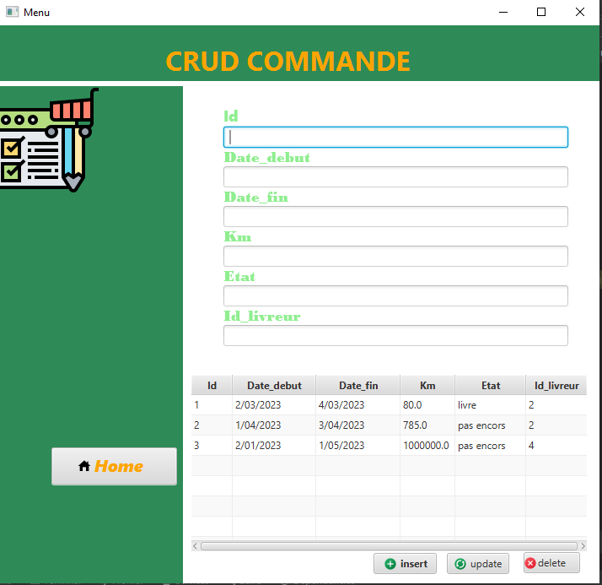

Classe Commande :

package ma.fst.trackingl_g2;

public class Commande extends Livreur {

private Long id_commande ;

private String date_debut ;

private String date_fin ;

private Float km ;

private String etat ;

public Commande(long id_commande, String date_debut, String date_fin, float km, String etat, Long id_livreur, String nom, String telephone) {

super( id_livreur, nom, telephone);

this.id_commande = id_commande;

this.date_debut = date_debut;

this.date_fin = date_fin;

this.km = km;

this.etat = etat;

}

public Long getId_commande() {

return id_commande;

}

public void setId_commande(Long id_commande) {

this.id_commande = id_commande;

}

public String getDate_debut() {

return date_debut;

}

public void setDate_debut(String date_debut) {

this.date_debut = date_debut;

}

public String getDate_fin() {

return date_fin;

}

public void setDate_fin(String date_fin) {

this.date_fin = date_fin;

}

public Float getKm() {

return km;

}

public void setKm(Float km) {

this.km = km;

}

public String getEtat() {

return etat;

}

public void setEtat(String etat) {

this.etat = etat;

}

}

Fichier Commande Fxml:

<?xml version="1.0" encoding="UTF-8"?>

<?import javafx.geometry.Insets?>

<?import javafx.scene.control.Button?>

<?import javafx.scene.control.Label?>

<?import javafx.scene.control.TableColumn?>

<?import javafx.scene.control.TableView?>

<?import javafx.scene.control.TextField?>

<?import javafx.scene.image.Image?>

<?import javafx.scene.image.ImageView?>

<?import javafx.scene.layout.AnchorPane?>

<?import javafx.scene.layout.VBox?>

<?import javafx.scene.text.Font?>

<?import javafx.scene.text.Text?>

<AnchorPane fx:id="root" prefHeight="629.0" prefWidth="712.0" xmlns="http://javafx.com/javafx/19" xmlns:fx="http://javafx.com/fxml/1" fx:controller="ma.fst.trackingl_g2.CommandeController">

<children>

<AnchorPane layoutX="-8.0" layoutY="-1.0" prefHeight="632.0" prefWidth="784.0" style="-fx-background-color: white;" styleClass="form_container" AnchorPane.bottomAnchor="-2.0" AnchorPane.leftAnchor="-8.0" AnchorPane.rightAnchor="0.0" AnchorPane.topAnchor="-1.0">

<children>

<VBox layoutX="274.0" layoutY="96.0" prefHeight="319.0" prefWidth="409.0" AnchorPane.leftAnchor="274.0" AnchorPane.topAnchor="96.0">

<children>

<Text fill="LIGHTGREEN" layoutX="10.0" layoutY="23.0" strokeType="OUTSIDE" strokeWidth="0.0" text="Id" wrappingWidth="26.259765625">

<font>

<Font name="Segoe UI Black" size="18.0" />

</font>

</Text>

<TextField fx:id="tid" layoutX="10.0" layoutY="68.0" />

<Text fill="LIGHTGREEN" strokeType="OUTSIDE" strokeWidth="0.0" text="Date_debut">

<font>

<Font name="Bodoni MT Black" size="18.0" />

</font>

</Text>

<TextField fx:id="tdated" />

<Text fill="LIGHTGREEN" layoutX="10.0" layoutY="124.0" strokeType="OUTSIDE" strokeWidth="0.0" text="Date_fin">

<font>

<Font name="Bodoni MT Black" size="18.0" />

</font>

</Text>

<TextField fx:id="tdatef" layoutX="10.0" layoutY="129.0" />

<Text fill="LIGHTGREEN" strokeType="OUTSIDE" strokeWidth="0.0" text="Km">

<font>

<Font name="Bodoni MT Black" size="18.0" />

</font>

</Text>

<TextField fx:id="tkm" />

<Text fill="LIGHTGREEN" layoutX="10.0" layoutY="171.0" strokeType="OUTSIDE" strokeWidth="0.0" text="Etat">

<font>

<Font name="Bodoni MT Black" size="18.0" />

</font>

</Text>

<TextField fx:id="tetat" layoutX="10.0" layoutY="176.0" />

<Text fill="LIGHTGREEN" layoutX="10.0" layoutY="218.0" strokeType="OUTSIDE" strokeWidth="0.0" text="Id_livreur">

<font>

<Font name="Bodoni MT Black" size="18.0" />

</font>

</Text>

<TextField fx:id="tliv" layoutX="10.0" layoutY="223.0" />

</children>

</VBox>

<TableView fx:id="mytable" layoutX="235.0" layoutY="414.0" onMouseClicked="#handleMouseAction" prefHeight="211.0" prefWidth="471.0" style="-fx-background-color: white;" AnchorPane.rightAnchor="14.0" AnchorPane.topAnchor="414.0">

<columns>

<TableColumn fx:id="col_id" prefWidth="49.0" style="color: white;" text="Id" />

<TableColumn fx:id="col_de" prefWidth="99.0" text="Date_debut" />

<TableColumn fx:id="col_df" prefWidth="100.0" text="Date_fin" />

<TableColumn fx:id="col_km" prefWidth="65.0" text="Km" />

<TableColumn fx:id="col_et" prefWidth="84.0" text="Etat" />

<TableColumn fx:id="col_liv" prefWidth="73.0" text="Id_livreur" />

</columns>

</TableView>

<Button fx:id="btdelete" layoutX="630.0" layoutY="625.0" mnemonicParsing="false" onAction="#handleButtonAction" prefHeight="25.0" prefWidth="67.0" text="delete" />

<Button fx:id="btupdate" layoutX="539.0" layoutY="626.0" mnemonicParsing="false" onAction="#handleButtonAction" text="update">

<graphic>

<ImageView fitHeight="16.0" fitWidth="16.0" pickOnBounds="true" preserveRatio="true">

<image>

<Image url="@icons8-syncronisation-connexion-16.png" />

</image>

</ImageView>

</graphic>

</Button>

<Button fx:id="btinsert" layoutX="452.0" layoutY="626.0" mnemonicParsing="false" onAction="#handleButtonAction" prefHeight="25.0" prefWidth="75.0" text="insert">

<graphic>

<ImageView fitHeight="16.0" fitWidth="16.0" pickOnBounds="true" preserveRatio="true">

<image>

<Image url="@icons8-ajouter-16.png" />

</image>

</ImageView>

</graphic>

<font>

<Font name="System Bold" size="12.0" />

</font>

</Button>

<ImageView fitHeight="16.0" fitWidth="26.0" layoutX="630.0" layoutY="630.0" pickOnBounds="true" preserveRatio="true">

<image>

<Image url="@icons8-annuler-16.png" />

</image>

</ImageView>

<VBox layoutY="73.0" prefHeight="591.0" prefWidth="226.0" style="-fx-background-color: #2E8B57;" AnchorPane.bottomAnchor="0.0" AnchorPane.leftAnchor="0.0" AnchorPane.topAnchor="73.0">

<children>

<ImageView fitHeight="128.0" fitWidth="128.0" pickOnBounds="true" preserveRatio="true">

<image>

<Image url="@bon-de-commande.png" />

</image>

</ImageView>

<Button mnemonicParsing="false" onMouseClicked="#home" prefHeight="44.0" prefWidth="149.0" text="Home" textFill="ORANGE">

<VBox.margin>

<Insets left="70.0" top="300.0" />

</VBox.margin>

<font>

<Font name="Segoe UI Black Italic" size="20.0" />

</font>

<graphic>

<ImageView fitHeight="16.0" fitWidth="16.0" pickOnBounds="true" preserveRatio="true">

<image>

<Image url="@icons8-page-d’accueil-16.png" />

</image>

</ImageView>

</graphic>

<padding>

<Insets right="10.0" />

</padding>

</Button>

</children>

</VBox>

<VBox layoutX="13.0" layoutY="52.0" prefHeight="67.0" prefWidth="720.0" style="-fx-background-color: #2E8B57;" AnchorPane.bottomAnchor="597.0" AnchorPane.leftAnchor="0.0" AnchorPane.rightAnchor="0.0" AnchorPane.topAnchor="0.0">

<children>

<Label alignment="CENTER" prefHeight="47.0" prefWidth="300.0" styleClass="title" text="CRUD COMMANDE" textFill="ORANGE">

<font>

<Font name="System Bold" size="32.0" />

</font>

<VBox.margin>

<Insets left="200.0" top="20.0" />

</VBox.margin>

</Label>

</children>

</VBox>

</children>

</AnchorPane>

</children>

</AnchorPane>

Fichier Commande Controller:

package ma.fst.trackingl_g2;

import javafx.collections.FXCollections;

import javafx.collections.ObservableList;

import javafx.event.ActionEvent;

import javafx.fxml.FXML;

import javafx.fxml.FXMLLoader;

import javafx.fxml.Initializable;

import javafx.scene.Parent;

import javafx.scene.control.Button;

import javafx.scene.control.TableColumn;

import javafx.scene.control.TableView;

import javafx.scene.control.TextField;

import javafx.scene.control.cell.PropertyValueFactory;

import javafx.scene.input.MouseEvent;

import javafx.scene.layout.AnchorPane;

import java.io.IOException;

import java.net.URL;

import java.sql.Connection;

import java.sql.DriverManager;

import java.sql.ResultSet;

import java.sql.Statement;

import java.util.ResourceBundle;

public class CommandeController implements Initializable {

private Parent fxml;

@FXML

private AnchorPane root;

@FXML

private Button btdelete;

@FXML

private Button btinsert;

@FXML

private Button btupdate;

@FXML

private TableColumn<Commande, String> col_de;

@FXML

private TableColumn<Livreur, Long> col_liv;

@FXML

private TableColumn<Commande, String> col_df;

@FXML

private TableColumn<Commande, String> col_et;

@FXML

private TableColumn<Commande, Long> col_id;

@FXML

private TableColumn<Commande, Float> col_km;

@FXML

private TableView<Commande> mytable;

@FXML

private TextField tdatef;

@FXML

private TextField tdated;

@FXML

private TextField tetat;

@FXML

private TextField tid;

@FXML

private TextField tkm;

@FXML

private TextField tliv;

@FXML

void handleButtonAction(ActionEvent actionEvent) {

if (actionEvent.getSource() == this.btinsert) {

this.insertRecord();

} else if (actionEvent.getSource() == this.btupdate) {

this.updateRecord();

} else if (actionEvent.getSource() == this.btdelete) {

this.deleteButton();

}

}

private void deleteButton() {

String query = "DELETE FROM commande WHERE id_commande =" + this.tid.getText() + "";

this.executeQuery(query);

this.showCommande();

}

private void updateRecord() {

String query = "UPDATE commande SET date_debut = '" + this.tdated.getText() + "', date_fin = '" + this.tdatef.getText() + "', km = " + this.tkm.getText() + ", etat = '" + this.tetat.getText() + "' WHERE id_commande = " + this.tid.getText() + "";

this.executeQuery(query);

this.showCommande();

}

public void insertRecord() {

String query = "INSERT INTO commande VALUES (" + this.tid.getText() + ",'" + this.tdated.getText() + "','" + this.tdatef.getText() + "'," + this.tkm.getText() + ",'" + this.tetat.getText() + "',( SELECT id_livreur FROM livreur WHERE id_livreur= "+ this.tliv.getText() + "))";

this.executeQuery(query);

this.showCommande();

}

private void executeQuery(String query) {

Connection conn = getConnection();

Statement st;

try {

st = conn.createStatement();

st.executeUpdate(query);

} catch (Exception e) {

e.printStackTrace();

}

}

@Override

public void initialize(URL url, ResourceBundle resourceBundle) {

this.showCommande();

}

public Connection getConnection(){

Connection conn;

try {

;

conn = DriverManager.getConnection("jdbc:mysql://127.0.0.1:3306/glovo","root","");

return conn;

} catch (Exception e) {

System.out.println("Error:"+e.getMessage());

return null;

}

}

public ObservableList<Commande> getCommandeList(){

ObservableList<Commande> commandelist = FXCollections.observableArrayList();

Connection conn = getConnection();

String query ="SELECT *FROM commande c JOIN livreur l ON c.id_livreur = l.id_livreur";

Statement st ;

ResultSet rs;

try {

st=conn.createStatement();

rs= st.executeQuery(query);

while (rs.next()){

Commande commande = new Commande( rs.getLong("id_commande"),rs.getString("date_debut"),rs.getString("date_fin"),rs.getFloat("km") ,rs.getString("etat"),rs.getLong("id_livreur"), rs.getString("nom"),rs.getString("telephone") );

commandelist.add(commande);

}

} catch (Exception e) {

e.printStackTrace();

}

return commandelist;

}

public void showCommande(){

ObservableList<Commande> list = this.getCommandeList();

col_id.setCellValueFactory(new PropertyValueFactory<Commande, Long>("id_commande"));

col_de.setCellValueFactory(new PropertyValueFactory<Commande, String> ("date_debut"));

col_df.setCellValueFactory(new PropertyValueFactory<Commande, String> ("date_fin"));

col_km.setCellValueFactory(new PropertyValueFactory<Commande, Float> ("km"));

col_et.setCellValueFactory(new PropertyValueFactory<Commande, String> ("etat"));

col_liv.setCellValueFactory(new PropertyValueFactory<Livreur,Long>("id_livreur"));

this.mytable.setItems(list);

}

public void handleMouseAction(javafx.scene.input.MouseEvent mouseEvent) {

Commande commande= mytable.getSelectionModel().getSelectedItem();

tid.setText(""+commande.getId_commande());

tliv.setText(""+commande.getId_livreur());

tdated.setText(commande.getDate_debut());

tdatef.setText(commande.getDate_fin());

tkm.setText(""+commande.getKm());

tetat.setText(commande.getEtat());

}

public void home(MouseEvent mouseEvent) {

try {

fxml= FXMLLoader.load(getClass().getResource("Menu.fxml"));

root.getChildren().removeAll();

root.getChildren().setAll(fxml);

} catch (IOException e) {

e.printStackTrace();

}

}

}

Creation base donnees : 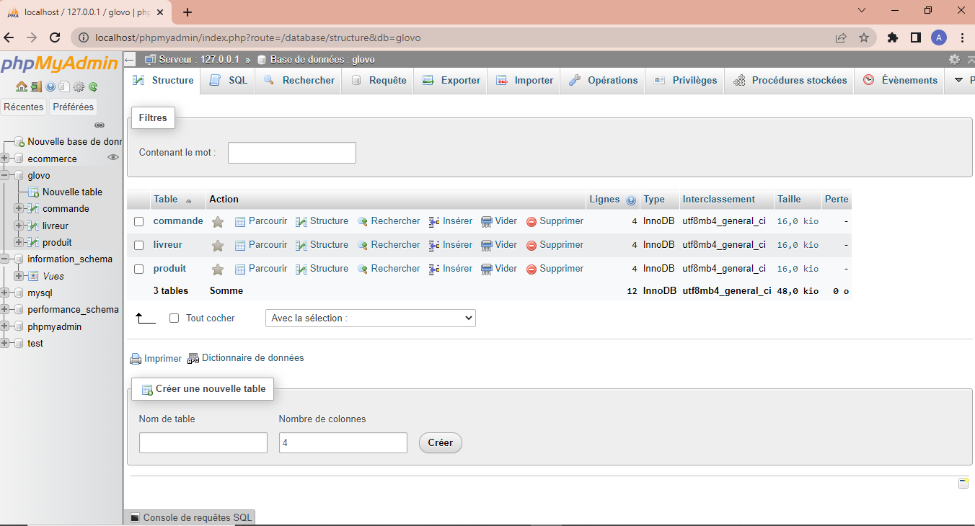

Table livreur : 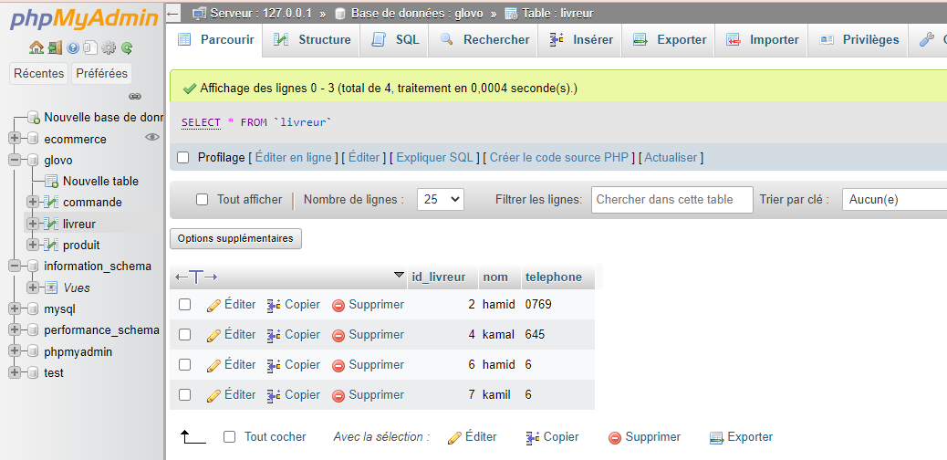

Table produit :

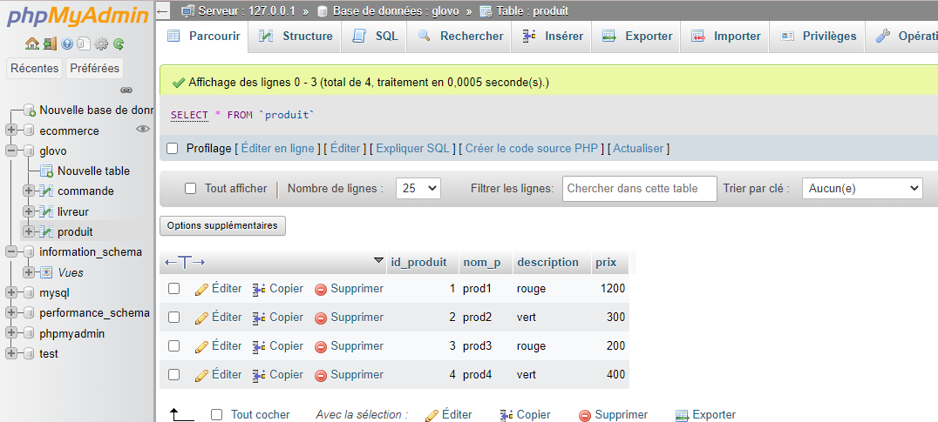

Table commande :

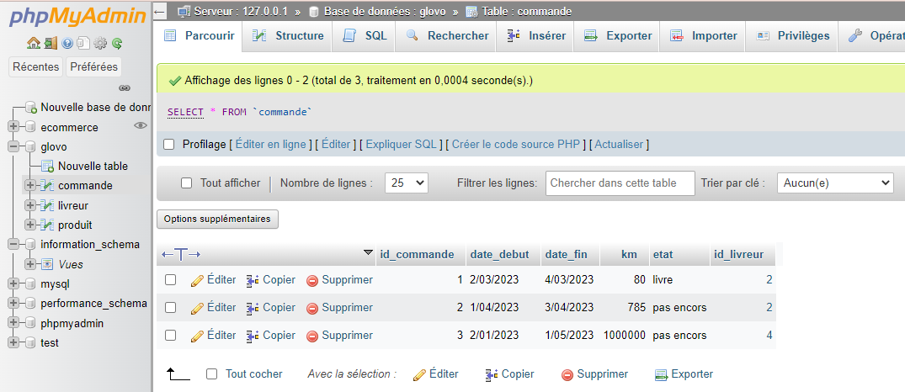

Conclusion :

Grace à cette application on a évolué notre connaissance de language java et l’utilisation de java et SQL avec l’utilisation des requêtes SQL.